I used all the 6400 claims of training set and their embeddings with 6,204 claims with 20 reasoning_traces and 196 claims with 15 reasoning_traces.
therefore, total embeddings:
- 20 traces + 1 claim * 6,204 total claims = 1,30,284 embeddings
- 15 traces + 1 claim * 196 total claims = 3,136 embeddings
- Training Matrix = ()

- done preprocessing:
- flatten
  - Maximum embedding= (20 + 1) * 1024d= 21504 (embedding with 20 reasoning_traces
  - 20 traces as it is
  - 15 traces -> padding with zeros with extra space
- splits:
  - 72% - train
  - 8% - validation
  - 20% - test
- done transformation for MLP task
  - changed mean=0 and std=1

- MLP:
Component | Value
Hidden Layers | 512, 256, 128
Hidden Activation | ReLU
Output Layer | 3 (False, True, Conflicting)
Output Activation | Softmax
Optimizer | Adam
Batch Size | 32
Learning Rate Strategy | adaptive
Initial Learning Rate | 0.001
Maximum Epochs | 500
Early Stopping | True
Validation Split | 0.1
Patience | 20

- 3 Layers (512, 256, 128):
  - 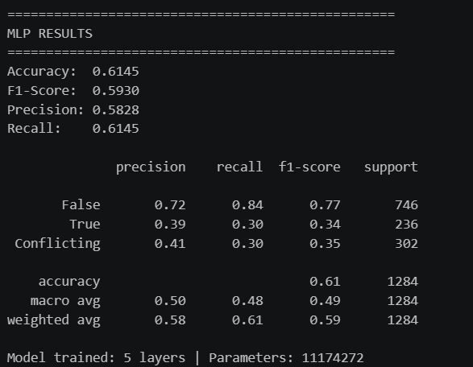
Avg. of F1 score and Recall = 0.60375
- 5 Layers (512, 256, 128, 64, 32):
  - 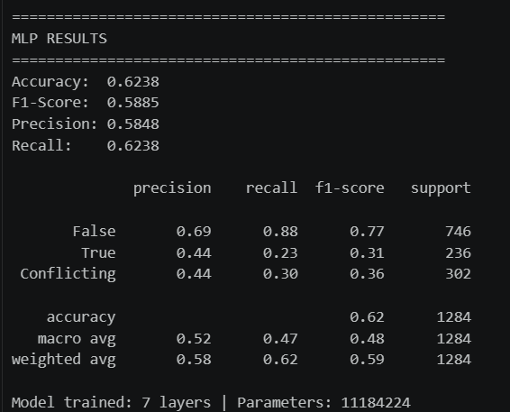
Avg. of F1 score and Recall = 0.60615

- XGBoost:
Component | Parameter | Value
Model Type | Algorithm | XGBClassifier
Ensemble Size | n_estimators | 200 Trees
Tree Depth | max_depth | 7
Learning Rate | learning_rate | 0.1
Row Sampling | subsample | 0.8
Feature Sampling | colsample_bytree | 0.8

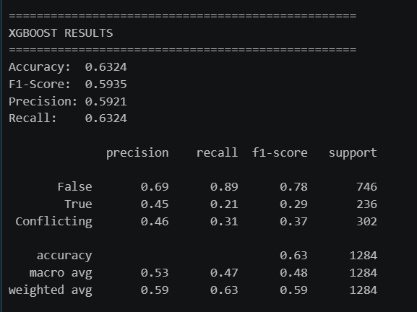
Avg. of F1 score and recall = 0.61295

